**A Research Proposal on**

**“Exploring the Relationship between Sowing Date and Growth, Yield in Chapa, West Rukum, Nepal”**

Principle researcher: Pratikshya Subedi

Exam roll no: 1668

Mobile no: 9817123403

Email:Pratikshyasubedi54@gmail.com

Collage name: Ramnagar technical and management collage

Responsible institution: Agriculture and Forestry University

Study location: Chapa-4, West Rukum

Duration of research: 5 months

Total budget: 30,000

Major Advisor:

Prof. Arjun Kumar Shrestha

Department of Horticulture

Directorate of Research

Site Supervisor:

Ravendra Pratap Yadav

Senior Agriculture officer

VSPC, Vegetable Seed Production Centre, West Rukum

Table of Contents

Acronyms and Abbreviations 4

Executive summary 5

1 INTRODUCTION 6

1.1Background information 6

1.2 Statement of Problem 7

1.3. Justification 7

1.4 Objectives 8

i. Board Objectives 8

ii. Specific Objectives 8

1.5 Hypothesis 8

2. LITERATURE REVIEW 9

2.1. Production status of Vegetables in Nepal 9

2.2. Status of planned development of vegetable seed in Rukum West 9

2.3. Status of vegetable production in Rukum West 9

2.4. Origin and evolution 10

2.5. Effect of sowing time in Yield and Growth 10

3. MATERIALS AND METHOD 11

3.1. Location of Experiment 11

3.2. Procurement of the materials 11

3.3. Selection of Treatment in the field 11

3.4. Experimental Setup: 12

3.6. Intercultural operation 14

3.7. Crop variety 14

3.8. Land Preparation and seed sowing 14

3.9. Fertilizers 14

3.10. Observations 14

3.11. Statistical analysis 15

3.12. Economic analysis 15

4. GANTT CHART 16

5. EXPECTED OUTCOMES 17

6. BENEFICIARIES 17

7. BUDGET SUMMARY 17

REFERENCES 18

# Acronyms and Abbreviations

Ha-Hectare

Mt-Metric tons

%-Percentage

Cm-centimeter

M-meter

M.sq-meter square

GDP-Gross domestic product

MOAD-Ministry of Agriculture Development

gm.: Gram

NGO/INGO: Non-Governmental Organization/International Non-government Organization

# Executive summary

Contender Bush Beans is a type of green bean that is popular among home gardeners and farmers. It is known for its high yield, disease resistance, and easy to grow nature. It is a type of snap beans, which means they are eaten whole when the pod is still young and tender. Bush beans are generally ready to harvest within 50-60 days of planting and can continue to produce for several weeks. Additionally, bush beans can help improving soil fertility by fixing nitrogen in the soil, making them a valuable crop in a sustainable manner. In conclusion, bush beans are a valuable and versatile crop that offers many benefits to gardeners, farmer and consumers. They are easy to grow, disease resistance and produce a high yield, making them an excellent choice for anyone interested in growing their own food. However, there are some limiting factor for the cultivation of bush beans such as lack of knowledge about the appropriate technology, poor selection and understanding of suitable variety, lack of cultivation management and adverse effect of environment. So, it is necessary to make the farmer understood about the sowing adjustment according to appropriate weather and conditions, appropriate technology should be disseminated among the people and they should be made aware of proper management practices. So, this study solely focusses on the optimum production of the beans by the proper sowing adjustment.

# 1 INTRODUCTION

1.1Background information.

French bean (Phaseolus vulgaris L.) (also called kidney beans, haricot beans, snap bean, navy bean and common bean) is one of the most important legume crops, grown for pulses as well as fresh vegetable. It can be grown in the wide range of soil and climatic condition (Schoon et al, 1991).French bean contains high amount of protein, vitamins, minerals. The leaves and stems are also good source of livestock fodder. French bean can be determinate (bush type) and indeterminant (Pole type). The determinant type does not need staking which is environmentally sound and can save extra inputs and operation. The bush type can be grown as sole crop, mixed crop or under orchard as intercrop. It can grow well under poor soil and management conditions which are common in the hills of Nepal. It also increases the soil fertility by fixing the atmospheric nitrogen and fit in the rice and maize-cropping pattern in the upland area.

Contender beans (*Phaseolus vulgaris L.cv, Contender*) are the popular variety of bush beans and is a native of South Carolina where it was developed by the Southeastern Vegetable Breeding Laboratory in Charleston and Introduced in 1961. McEwen, J., Yeoman, D. P., & Moffitt, R. (1988). It is the most cultivated leguminous tender warm weather annual vegetable in the world and is the most important food legume. Contender beans produce green, tender pods that are stringless and about 5-6 inches long and feature erect stems, green spade shaped leaves, 57 green snap bean pods, and tiny white flowers. The plant can be grown on the contender attract bees and butterflies, creates biomass makes dye and fabric and is both edible and medicinal. They are known for their high yields, early maturity, and disease resistance. They are sometimes referred to as string beans or snap beans.

Contender beans were developed by Harris Moran Seed Company in the United States. They are believed to be a result of selective breeding and hybridization of different bush beans varieties. Contender beans were first introduced to the market in the1940s and have since become a popular choice for the home gardeners due to their high yield. In Nepal it is cultivated extensively in the mid and high hills.

The plants themselves are compact and do not require staking or trellising, which makes them easy to grow in small spaces. The pods of the contender beans are typically harvested when they are young and tender, before the seeds inside have fully developed. Chatterjee, R., & Som, M. G. (1990). This results in a crisp, juicy texture and a sweet flavor. Contender beans are the good source of fiber, protein, and vitamins and minerals such as vitamin C, Vitamin B and folate. This vegetable not only plays a vital role in nourishment of human population but also improve soil fertility to a greater extend by the virtue of being highly nitrogen fixing crop.

Contender beans like other legumes, have the ability to fix the nitrogen in the soil through the symbiotic relationship with certain types of bacteria. These bacteria convert the atmospheric nitrogen into a form that can be used by the plant, which can then enhance soil productivity. This relationship with nitrogen-fixing bacteria allows Contender beans, it is important to provide the right condition for these bacteria to thrive.

This include maintaining proper soil pH, providing adequate moisture, and avoiding excessive use of nitrogen fertilizer, which can inhibit nitrogen fixation. In addition, it is important to inoculate the soil or growing medium with the appropriate strain of rhizobia bacteria to ensure successful nitrogen fixation. This can be done by purchasing the inoculant products or by using the soil from a previous crop of legumes. Overall, the relationship between the Contender beans and the nitrogen fixation is a unique and important aspect of their growth and productivity.

In general, contender beans prefer warm, sunny weather with temperature between 60 and 85° Fahrenheit (15 to 29° Celsius). They require well drained soil with a pH level between 6.0 and 7.0.Contender beans are relatively tolerant of drought and can survive in dry conditions as long as they receive regular watering. However, they are susceptible to the frost damage and should not be planted until the danger of frost has passed. In terms of rainfall, Contender bean require a moderate amount of water. They prefer a well-drained soil that is kept moist but not waterlogged. Overwatering can lead to fungal disease and root rot, which can damage or kill the plants.

However, there are some limiting factors to cultivate and produce the bush type French beans in the hills of Nepal. (Bhattarai et al, 1997) Reported that the main problems are lack of suitable varieties for the wider adaptation and large-scale production of the bush beans, lack of suitable practices, disease and pest control, adverse effect of climate during the entire season of crop production.

## 1.2 Statement of Problem

Since French bean is newly introduced crop, technology for its cultivation is not well developed in Nepal. Due to which the average yield (1.9t/ha) of French bean obtained in the farmer field of Chitwan (DADO, 2007) is low as compared to its potential (3.0 t/ha) yield (Yadav, 2000). In context of Nepal information regarding the appropriate time of sowing of beans is not sufficient .Due to the lack of awareness among people about the sowing date adjustment according to the climactic pattern which has created an adverse effect in the growth and yield of the contender beans has been the problem on the yield reduction. For instance, the bean sown in the late April may have the greater influence of rainfall at the time of harvesting in this place which lies in the mid hill region .Such type of erratic and excessive rainfall leads to the difficulty in harvesting which can cause flooding and damage or destroy the plants and reduce the yield of beans .likewise, harvesting the beans during rainy season can be challenging due to the muddy and slippery condition, which can make it difficult to move around the farm and harvest the beans without damaging them. Moreover, the changing climatic condition has always threatened the production system of many crops including bush bean.

Hence, due to the lack of research on the proper time of sowing. Farmers are unable to exploit the yield potential of the Contender beans under West Rukum and other similar agro-climatic condition of Nepal.

## 1.3. Justification

Contender bean is the newly introduced crop in case of Nepal, technology for its cultivation is not developed in Nepal. Likewise, very few researches have been done in this bean. As our country has a huge climatic variation, research in one agro-climatic zone is not reliable to follow in each and every place. Time is the priceless resources in agriculture sector which plays an important role for the crop success. Thus, optimum sowing time is one of the important adaptive farming practices for the successful, crop production which not only make correct choice of planting but also allows crop to escape from adverse weather condition to prevent crop failure or loss. To find out the appropriate time of sowing in the crop in the Rukum will help to follow by the farmers of the similar agro-climatic condition i.e., Mid-Hill Belt of Nepal

Therefore, the research will determine the impact of sowing date on the quality, quantity and rust disease of beans. Good yield of the Contender beans will increase the livelihood of the people who grow the beans in the marginal land managing the irrigation and the fertilizer requirement along with the proper spacing. The findings about the date of sowing followed under the farmers condition for better yield will ultimately help to uplift the economic standard for farmers. Although several studies have been conducted in the sowing time in various part of the world, there is the limited information under the Nepalese condition to recommend the sowing time. Moreover, no research has been reported of sowing date at the appropriate time to the yield of contender bean under the Rukum climatic condition.

## 1.4 Objectives

### i. Board Objectives

To determine the effect of date of sowing on the growth, and yield of beans.

### ii. Specific Objectives

1. To know about the relationship between the date of sowing and growth, and yield of beans.
2. To determine the ideal time to plant the beans to optimize the yield and quality under the varying environment conditions such as temperature, precipitation and photoperiod.
3. To provide the valuable insight into the growth and development of the contender beans under different sowing dates, such as the time required for germination, flowering and pod formation.

## 1.5 Hypothesis

Null hypothesis (H0): All the treatment are equal in the production yield of Contender beans

Alternative hypothesis (H1): All the treatment is not equal in the production of yield of French beans

# 2. LITERATURE REVIEW

## 2.1. Production status of Vegetables in Nepal

Agriculture has been serving as the backbone of the Nepalese economy contributing about 26.50 per in the national economy .Gross Domestic Product,(GDP) (Dinesh Bahadur Basnet,Prof Komal bahadur Basnet,Prakash Acharya, 2022) .In agricultural sector ,horticulture contribute16.75 %,within which vegetable contribute 9.17% ,fruit and spices contribute 7.04% in the national agricultural GDP (Finance), 2015).

In 2021, Vegetable primary production for Nepal was 4.18 million tons. Between 1972 and 2021 the vegetable primary production grew substantially from 200,000 to 4.18 million tones raising at an increasing annual rate that reached maximum of 33.33% in 1997 and then decreased to 0.26% in 2021. (Corporation, 2021).According to the (MoALD, 2020/2021), the area of 284,121 ha has been used for the vegetable production, which has the productivity of 3,999,167 mt and yield of 14.05 mt/ha. The inconsistent climatic condition has led to the fluctuating trend in the cultivation and production of vegetable subsector in Nepal. (Pandey et al, 2017).According to dietician and nutritionist the average per capita daily requirement of vegetable is 300gm per person. (USAID Nepal, 2011) but intake is extremely poor as compared to standard requirement with the deficit of 60 % (Gautam and bhattarai, 2006).

2.2. Status of planned development of vegetable seed in Rukum West.

Vegetable seed enterprise is a highly potential sub-sector for the economic growth of rural farmer in Nepal (Pun, A. B., & Poudyal, D., 2018).Rukum has long been known as the most potential district for the vegetable seed production in Nepal (Amar Bahadur Pun ,Damodar Poudyal, 2018).The diverse agro-climatic from warm sub-tropical to cool temperate Himalayan range offers tremendous scope of growing the seed of various vegetable in Rukum (Subodh Dhakal,Gopi Krishna Sedain ,Subas Chandra Dhakal, 2013).Only 50% of domestic demand of seed has been made over the past decade (KUBK, 2015).In addition ,the district has a great opportunity to fetch the increasing domestic as well as export market of vegetable (Joshi, DDC, 2015).

However, there are some limitations on the vegetable seed production and marketing in this district. First, seed marketing is not yet well organized with proper grading ,standard packaging and labeling because of lack of quality control service (Shivakoti, Timsina, 2022). Secondly low level of knowledge and capacity at the farm level are also the major constraints. (MoAD, 2013).

2.3. Status of vegetable production in Rukum West.

In the context of Rukum West, the area of vegetable production was 2172 hac and the production was around 27476 mt in the year 2071/2072 (DADO. 2015. , 2074/75). The productivity was found to be increased in the year 2072/2073 and it was 12.8 hac (PMAMP, Annual Progress Report, 2074/2075). In the year 2077/78, Onion was cultivated for the seed production as a major crop in a large scale but unfortunately beans production was not done. As per the sample survey it is estimated that in this fiscal year 2078/2079, bean has been cultivated in an area of 7 ropani with the production target of 250 kg and indeed people are more engaged and motivated in vegetable cultivation with the service provided by the Vegetable Seed Production Centre (VSPC).

## 2.4. Origin and evolution

Common Beans (Phaseolus vulgaris is l=2n=2x=22) is grown in all the continents except Antarctica. The principal product is green beans (harvested at the physiological maturity) and the green beans (Pod harvested before the seed development phase) According to the data published by FAO, World Production of snap beans was estimated at 18,639,095 tons in 1996 (FAO, 1997). Production in US in 1994 was 1,323,922 tons (Department of agriculture 1999) Wild and cultivated gene pool in common beans. The current organization of genetic diversity in the cultivated gene pool of the common bean is the result of evolution under the natural condition. Before domestication, Wild beans has already diverged into two major gene pool, each with its characteristic’s geographic distribution in Mesoamerica and Andes. In addition to these 2 major gene pools, recently discovered wild bean population constitute a third distinct geographical segment of particular significance for the evolutionary history of common beans (Debouck, 1993).These two gene pool can be distinguished at the morphological and molecular level (Becerra,velasquez and gepts, 1997).

## 2.5. Effect of sowing time in Yield and Growth

The ideal time for planting Contender beans is the most important to higher productivity. Planting on Mid-November was the most suitable sowing time to get the maximum seed yield as reported where the two varieties Bhari-Jhar Simi -1 and Bhari Jhar Simi -2 of French beans were compared as reported. (MONIRUZZAMAN1, 2007). However lack of information about proper variety selection and sowing date adjustment yield obtained was far below the potential.

With the objective of evaluating the effect of wind break and sowing date on the yield of different bean varieties there was significant decrease in the yield sown later in all 2 years of research. Yoldas, F., & Esiyok, D. (2007) and the better result was obtained using the maize as a wind break.

Twenty genotypes of French beans containing the contender beans was investigated under the net house (Protected) condition in Punjab evaluated for the quality parameter such as dry matter, sugar content and the fiber content where these offseason crop can fetch higher price in the market and economical to the farmer. (Jitendra Meena*, 2020).

To improve the future nutrient management practices in the beans and potato that were adequate for N, Ca, Mg but deficit in P and K along with the intercropping, cultivar trait, crop density, time of sowing and spacing which contributed to the above and below ground nutrient availability and overall field performance were considered with the view to provide the ecosystem service too. Wilton, M., Karagatzides, J., & Tsuji, L. (2017).

The Rajmah anthracnose (*C.lindemuthianum*) emerged out to be the thread to the successful cultivation of crop and reported as the most destructive disease of rajmah causing 30to 70 percent loss throughout the world. (A. S. Padul, 2017)

Date of sowing has the great influence in the plant height, pods per plants and grain yield. The plant height decrease gradually with delayed sowing , number of pod per plant is highest in the plant sown in October 16th which was followed by October 31st , October 1st and November 15th and maximum grain yield was obtained in October 16th . (Dutta. V.K., D.N Pokhrel, & Maharjan, 2002)

# 3. MATERIALS AND METHOD

## 3.1. Location of Experiment

The field experiment will be conducted at Vegetable and Seed Production Centre (VSPC) located at the Chapa-4, Musikot Municipality, West Rukum. This location is situated at 28° 44.6065'. N latitude and 82° 28.5166' E longitude with the elevation of 1575 m. This location falls in the mid-hill region of Mid-Western Development Region of Nepal.

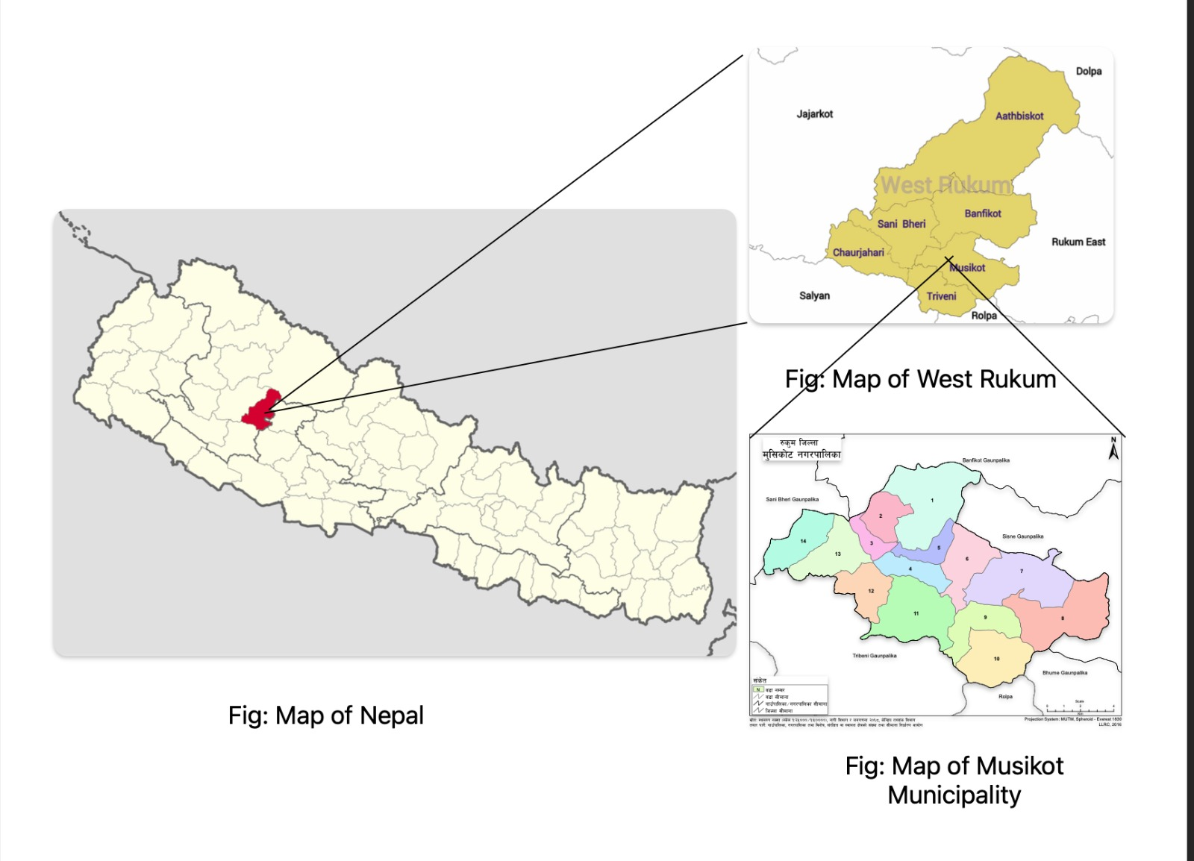

Fig: Map of Location of experiment

## 3.2. Procurement of the materials

Seeds of selected contender bush bean and required amount of NPK will be given by the farm office itself. The required amount of FYM will be used as it will be available in the farmer’s field.

## 3.3. Selection of Treatment in the field

Total of five treatment with four replication is applied in the field with the:

1st date of sowing (T1): 17th February (Falgun 5)

2nd date of sowing (T2): 4th march (Falgun 20)

3rd date of sowing (T3): 19th march (Chaitra 5)

4th date of sowing (T4): 3rd April (Chaitra 20)

5th date of sowing (T5): 18th April (Baisakh 5)

## 3.4. Experimental Setup:

The field experiment will be carried out in the Vegetable Seed Production Centre (VSPC), Chapa-4, West Rukum. The experiment will be conducted in simple RCBD (Completely Randomized Block Design) with the 4 replications. Treatment will be date of sowing i.e.; 17th February, 4th March,19th March, 3rd April, 18th April. The space between the rows will be 65cm and the space between the plants will be 30cm.The net area of each plot will be2.89m2 (1.7m*1.7m) and total area of the field will be 110m2 (11m*10m). Plot will be separated by 50cm space within the plot and 1m space between the block. Similarly the border between the block and the outside field will be 30cm.Seed will be sown in the furrow .For irrigation pipe channels will be provided .At the time of land preparation 10 t/ha FYM will be applied, Total amount of P and K will be applied 3:5 kg /ropani and half dose of nitrogen will be applied, Total amount of phosphorous and potash will be mixed at the time of land preparation and remaining half of the nitrogen will be applied at 45 DAS of planting. Seed will be soaked overnight one day before planting. Weeding, Sanitation and irrigation will be done in each plot.

**3.5. Experimental design**

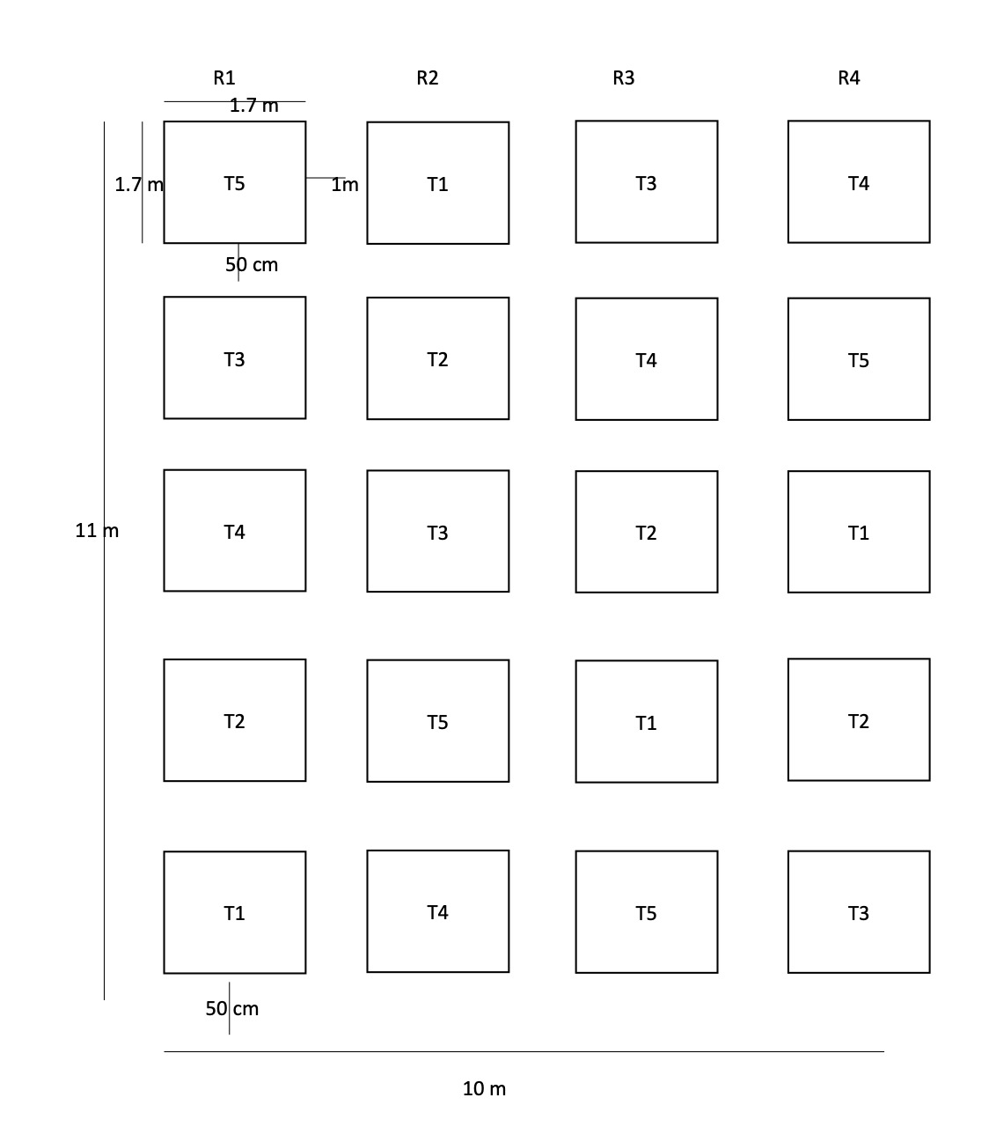

## 3.6. Intercultural operation

One hoeing, irrigation twice in a week, nitrogen fertilizer application half at the time of sowing and half at the time of 45DAS of sowing. Weeding and other plant protection measures will be carried out as per the requirement. Harvesting and threshing will be done manually

## 3.7. Crop variety

Contender variety of the bush bean will be selected for the experiment as it is produced in this farm and suitable for the mid –hills. It is of determinant type, stringless and disease resistance.

## 3.8. Land Preparation and seed sowing

Before seed sowing, the land will be ploughed thoroughly. After that the field will be divided into the plot size of 1.7*1.7 m.sq. Again the 2nd ploughing will be done a week after the first ploughing and will be levelled accordingly. Row to row spacing will be 65 cm and plant to plant will be 30cm.The seed will be sown at the depth of 3-4 cm .

## 3.9. Fertilizers

Recommended dose of NPK will be applied at the rate of 3:3:5 kg per ropani the form of Urea, DAP, MOP. Nitrogen will be applied at the split dose through urea (46%N) half at the basal dose and remaining half after 45 DAS of Sowing and phosphorous and potassium will be mixed and applied at the basal dose through DAP (18%N and 46%P) and MOP (60%K). FYM will be applied at 10tons/ha at the time of field preparation.

## 3.10. Observations

The data pertaining to the following parameters will be recorded during research period. For this, 5 plants will be selected randomly in each plot to take data every time in certain interval of time.

Weather data during the crop season

The meteorological data such as temperature (maximum and minimum temperature), Wet and dry temperature, sunlight, relative humidity and rainfall will be recorded during the cropping period from the agro meteorological station present in the Vegetable Seed Production Center, Chapa-4, Rukum.

Yield and yield attributing character of beans.

Growth Parameters

1. Plant height at 30, 45 ,60 DAS
2. Number of leaves / plants at 30,45,60 DAS
3. Number of branches / plants at 30,45,60 DAS
4. Leaf area index at 30,45,60 DAS

Flower characters:

1. Days to flowering
2. Days to 50% flowering

Fruit and yield attributes:

1. Pod length
2. Pod diameter
3. Pod weight
4. Number of seed /pods
5. Number of pod/ clusters
6. Number of cluster / plants
7. Pod yield/plot

## 3.11. Statistical analysis

The data will be tabulated in Microsoft Excel and statistically analyzed by using MSTAT-C and GenStat Packages. The data will be analyzed and the findings will be discussed and related with available literature.

## 3.12. Economic analysis

Cost of cultivation will be calculated on the basis of local rates of inputs used during the researches, gross return will be calculated from the value of grain yield/ha and the difference of the gross return and the cost of cultivation will be the net return obtained. The benefit cost ratio will be calculated for the purpose of economic analysis.

ANOVA TABLE

The ANOVA table for the RCBD with five treatments in four replications

|  |  |  |  |  |  |
| --- | --- | --- | --- | --- | --- |
| Source of Variance | Degree of freedom (df) | Sum of Square (SS) | Mean sum of square (MSS) | Calculated ‘F’ value | Tabulated ‘F’ value |
| Replication | r-1=3 |  |  |  | 0.05 0.01 |
| Treatment | t-1=4 |  |  |  |  |
| Error | (r-1) *(t-1) =12 |  |  |  |  |
| Total |  |  |  |  |  |

# 4. GANTT CHART

|  |  |  |  |  |  |
| --- | --- | --- | --- | --- | --- |
| Activities | March | April | May | June | July |
| Literature review |  |  |  |  |  |
| Field visit and problem identification |  |  |  |  |  |
| Site Selection for experiment |  |  |  |  |  |
| Land Preparation and manuring |  |  |  |  |  |
| Field layout and sowing |  |  |  |  |  |
| Intercultural  Operation |  |  |  |  |  |
| Observation and data collection |  |  |  |  |  |
| Data entry and analysis |  |  |  |  |  |
| Report writing and presentation |  |  |  |  |  |

Fig: Gantt Chart

# 5. EXPECTED OUTCOMES

Existing farmers practice compared with the finding of effect of date of sowing on the growth and yield of bush bean will be determined

The effect of individual treatment to the yield of Contender beans will be determined.

Interaction between the sowing date with the growth, yield and anthracnose disease of beans will be assessed.

Appropriate time of sowing in beans will be specified by the research result.

The result will be used by the extension worker and farmer of this region.

# 6. BENEFICIARIES

Primary: Bush bean grower who will be involved in commercial beans cultivation.

Secondary: Academicians, researchers, Horticulturists, teachers and students

Tertiary: Institution, extension work, policy makers, the developmental organization such as DADO, NGO, INGO.

# 7. BUDGET SUMMARY

|  |  |  |
| --- | --- | --- |
| SN | Particulars | Amount |
|  | Land Preparation | 1,500 |
|  | Layout of field | 1,500 |
|  | Plastic rope, polybags | 1,000 |
|  | Manure and fertilizers | 3,000 |
|  | Seed and Seed Sowing | 2,000 |
|  | Intercultural operation | 4,000 |
|  | Insecticides and Spray | 2,000 |
|  | Measurement of growth parameters and yield attributing characters | 1,500 |
|  | Harvesting | 3,500 |
|  | Data entry and analysis | 3,000 |
|  | Stationary, Photocopies, printings | 2,000 |
|  | Final presentation | 3,000 |
|  | Sub total | 2,75,00 |
|  | Contingency |  |
|  | Total |  |

# REFERENCES

(n.d.).

A. S. Padul, e. a. (2017). Effect of Date of Sowing on Anthracnose of Rajmah. *ISSN*, 2546-2553.

Amar Bahadur Pun ,Damodar Poudyal. (2018). Assesement of Present Status and action plan development of Vegetable seed enterprise in Rukum,Nepal. *Journel of agriculture and Natural science*, 122-132.

Becerra,velasquez and gepts. (1997). Origin of Agriculture and Crop domestication. *International centre for agriculutre research*.

Bhattarai et al. (1997). Effect of Mycorrhiza aand rhizobium on thePhaseolus Vulgaris. *Nepal Acedemy of Science and Technology( NAST)*. Retrieved from https://www.nepjol.info

Corporation, K. (2021). Department of Agriculture Cooperation and Farmers Welfare, India. Retrieved from https://knoema.com

DADO. (2007). *Annual Report.* Chitwan,Nepal: District Agriculture Development office. Retrieved from http://forwardnepal.org

DADO. 2015. . (2074/75). *Annual Progress Report .* Rukum khalanga, Nepal: District Agriculture Development Office .

Debouck. (1993, September 15). Factors affecting the Adoption of Sustainable Development. *22*(2), 159-165. doi:http://doi.org/10.1017/S1068280500004743

Dinesh Bahadur Basnet,Prof Komal bahadur Basnet,Prakash Acharya. (2022). *Effect of Date of Sowing of French bean (Phaseolus Vulgaris L) in minimizing climate change impact and its performancein inner terai region of Nepal.* NARC, Internationational Journal of Environment Agriculture, Khumultar,Lalitpur,Nepal. Retrieved from http://ijeab.com

Dutta. V.K., A., D.N Pokhrel, A., & Maharjan, R. A. (2002). Response of Rajma Bean (Phaseolus vulgris L) to different dates of sowing and spacing . 73-75. Retrieved from https://opac.narc.gov.np

Finance), M. o. (2015). *Economic Survey.* Govermnent of Nepal. Retrieved from https://www.mof.gov.np

Gautam and bhattarai. (2006). Postharvest horticulture in Nepal. *Horticulture International Journal*.

Jitendra Meena*, T. S. (2020). STUDIES ON PERFORMANCE OF FRENCH BEAN (PHASEOLUSVULGARIS L.) GENOTYPES FOR YIELD AND QUALITY TRAITS UNDER PROTECTED CONDITIONS. *Plant Archive*, 615-619.

Joshi, DDC. (2015). *Seed Development Enterprise in Nepal: Oppurtunities and challenges.* Kathmandu: Seed quality control centre.

KUBK. (2015). *Improved Seed for Farmers Programme.* Nepal: International fund for Agricultural Development. Retrieved from http://www.ifad.org

L.Whitten, J. (1999). Washington ,D C: United State of Agricuture Department.

MoAD, 2013. (n.d.). Nationl Seed Vision 2025,Ministry of Agriculture development(MOAD),Kathmndu Nepal. *Journl of Agriculture and Natural Science,*.

MoALD. (2020/2021). *Statistical Information on Nepalese Agriculture.* Planning and Cooperation Cordination Division. Retrieved from http://moald.gov.np

MONIRUZZAMAN1, M. (2007). PERFORMANCES OF VEGETABLE FRENCH BEAN AS INFLUENCED BY VARIETIES AND SOWING DATE IN RABI SEASON. *Int. J. Sustain. Crop Prod. 2(5):69-73*, 70-72.

Pandey et al. (2017). Impact of combined abiotic and biotic stresses on Plant. *Nepal Agricultural Council*.

*PMAMP, Annual Progress Report.* (2074/2075). Kathmandu,Nepal: Ministry of Agriculture and Livestock Development.

Pun, A. B., & Poudyal, D. (2018). Assesment of Present Status and actio plan development of vegetable seed enterprise in Rukum west. *Journal of agriculture and Natural Resource*, 122-132. Retrieved from https://www.nepjol.info

Schoon et al. (1991). Value of Farmer ,Sustainablity and Agricultural policy. *Journal of Agricuture and Environment ethics*, 349.

Shivakoti, Timsina. (2022, June 25). Assesment of the Spatial Distribution and Mapping Soil Physio-chemical Properties of Nalgad Municipality ,Jajarkot,Nepal. *Journal of Online Nepal, 23*.

Subodh Dhakal,Gopi Krishna Sedain ,Subas Chandra Dhakal. (2013). Climate Change Impact and Adaptation Practices in Agriculture:A Case Study of Rautahat District. *Climate*, no4:63. doi:http://doi.org 10.3390/4040063

Yadav. (2000). *Production technology of Rajma.* Rampur,Chitwan: National Agriculture Researh Council,National Grain Legume Research Program.